**PROJECT DOCUMENT**

DATA VISUALISATION USING

TABLEAU

TITLE: **CRIME ANALYSIS IN INDIA**

BY

ANUSHA KP

**AGENDA**

1. INTRODUCTION……………………………………………… 01
2. CRIMES IN INDIA…………………………………………….. 02
3. CRIME ANALYSIS……...………………………………………03
4. PROBLEMS FACED BY POLICE DEPARTMENT……………04
5. PARAMETERS USED FOR ANALYSIS……………………….05
6. CONCLUSION…………………………………………………..06
7. REFERENCE…………………………………………………….07

**INTRODUCTION**

* In today’s world crimes are on the rise, misuse of technology and various socio economic factors have led to global increase of crimes.
* Analysis of the crime scenario, the data obtained and determination of probable suspect is a challenge.
* The existing crime analysis system work on the traditional mechanisms, processes and methods.
* The process of criminal identification in India is commonly executed using traditional method.
* The police stations use a database system to store the criminal information and access the database when criminal information is required. Crime patterns are changing all the time and growing.
* The crime data previously stored from sources has a tendency to increase. The management of this data and analysis of the data is very difficult. Thus it can be said that crime data analysis is fundamental to effective prevention of crime.
* However to improve traditional system ,a system has been proposed that operates on utilizing criminal data and its analysis
* The analysis basically means storing the criminal data in a particular format, analyzing the stored data to find criminal and deriving conclusions and visualisations from the analyzed data.
* This would ensure law enforcement function which involves systematic analysis for identifying and analyzing criminal and its trends in crime and disorder.

**CRIME IN INDIA**

The Indian Penal Code, 1860 provides the following classification for the purpose of categorizing crimes:

1. Inchoate crimes (abetment, criminal attempt, criminal conspiracy)
2. Offences affecting the state (waging war, assaulting the president, offences relating to the forces etc.)
3. Offences affecting common well-being (Relating to public tranquillity, public servants, elections etc.)
4. Offences affecting Human Body (Affecting life like murder, homicide, causing miscarriage, hurt or grievous hurt etc.)
5. Offences against Property (Theft, extortion, criminal breach of trust, offences relating to documents and property marks etc.)
6. Offences relating to marriage (Cruelty, adultery etc.)
7. Offences affecting reputation (Defamation, criminal intimidation, insult and annoyance etc.)

While classifying crime, different states may classify it from different perspectives but broadly, the crimes can be classified into the following 4 categories:

1. Crime against a person
2. Crime against the public at large
3. Inchoate Crimes
4. Statutory Crimes

**CRIME ANALYSIS**

Crime analysis is both a profession and a set of techniques. The professionals who perform crime analysis, and the techniques they use, are dedicated to helping a police department become more effective through better information. The information that analysts provide can help:

* Solve crimes
* Develop effective strategies and tactics to prevent future crimes
* Find and apprehend offenders
* Prosecute and convict offenders
* Improve safety and quality of life
* Optimize internal operations
* Prioritize patrol and investigation
* Detect and solve community problems
* Plan for future resource needs
* Enact effective policies
* Educate the public

Some crime analysts work for large police departments, some work for small ones. Some are civilian career professionals; others are police officers in temporary or permanent assignments. Although the profession has long been called *crime* analysis, in truth many analysts spend most of their time looking at non-criminal incidents, including disorder calls, noise, domestic disputes, and traffic accidents. Some departments use the terms “public safety analysis” or “police information analysis” instead.

**PROBLEMS FACED BY POLICE DEPARTMENT**

* Indian Police Department has given the crime data of 2020 to 2024.
* Higher Officials of Police department of India will be taking major decisions on the upcoming year 2025 based on this data.
* This data consists of crimes which happened overall India and closure status as well.
* Police department’s purpose is to analyse the crime rates in top metropolitan cities.
* Major problems faced by police department is to find the top 10 cities with highest crime rates.
* They need to check whether in 2024 comparing to 2020-2023 crime rate in the top cities has reduced or not.
* What type of weapons are mostly used when doing crime in these cities.
* Case closure rates need to be known.

**PARAMETERS USED FOR ANALYSIS**

**a. Crime Trends Over Time:**

1. Year by year case reported numbers are analysed and presented as a visualisation.
2. Visualisation chart used here is line chart.
3. As a Tableau analyst, I am helping the police department of India to analyse the case reported trends from 2020 to 2024.
4. Through this they can easily identify case reported yearly and monthly.

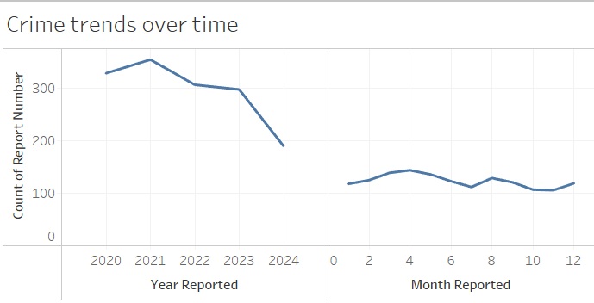

* + 1. CRIME TRENDS OVER TIME

**b.Top 10 Cities with Highest Crime :**

1. Police department’s main aim is to check the cities with top crime rates.

2. In this top 10 cities are listed which has highest crime rates.

3. Visualisation chart used here is Horizoantal Bar Chart.

4. The bars represents the total number of reported cases in all the top 10 cities.

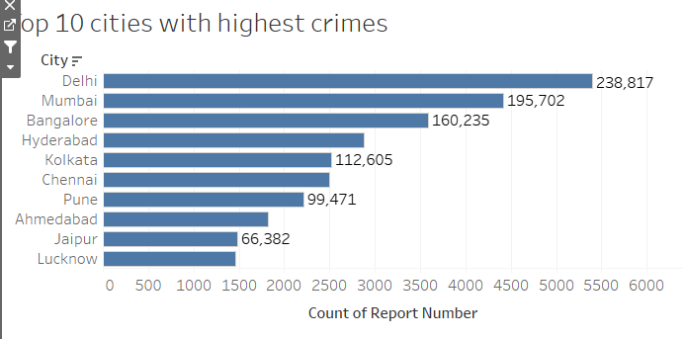

* + 1. TOP 10 CITIES WITH HIGH CRIMES

**c. Case Closure rates by Crime Domain :**

1. Case closure rates plays a vital role for the police department to check the performance of the police department for the top 10 cities.

2. There are two categories of cases:

* Solved Cases

* Unsolved Cases

3. This visualisation is used to check the case status for the top 10 cities.

4. Visualisation chart used here is stacked bar chart.

5. Stacked bar charts are used to check the two categories.

6. Police department can easily sort out the number of cases solved and unsolved using this visualisation.

7. This helps the department to take some important decisions of top 10 cities police department performance.

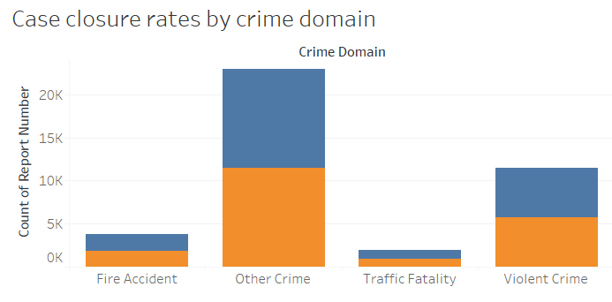

* + 1. CASE CLOSURE RATES BY CRIME DOMAIN

**d)Victim Gender Distribution :**

1. Here, we have identified the victim genders who were affected during the crime.

2. Female victims holds the first place -22,423 Female got affected during the crime.

3. Male victims holds the second place -13,405

4. Either male/ female/transgenders hold the third place which is represented as X- 4332

5. Visualisation chart used here is Vertical Bar Chart.

6. Through this the police department can identify in each top cities how much genders were affected during the crime.

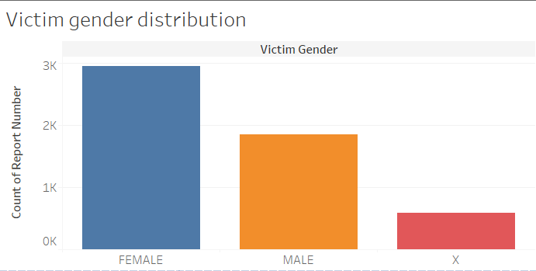

d)VICTIM GENDER DISTRIBUTION

**e) Police Deployment:**

1. Police deployment status of top 10 cities are analysed and visualised.

2. Visualisation is done in the form of horizontal bar chart.

3. This helps the police department to check the police deployed status in the top 10 cities.

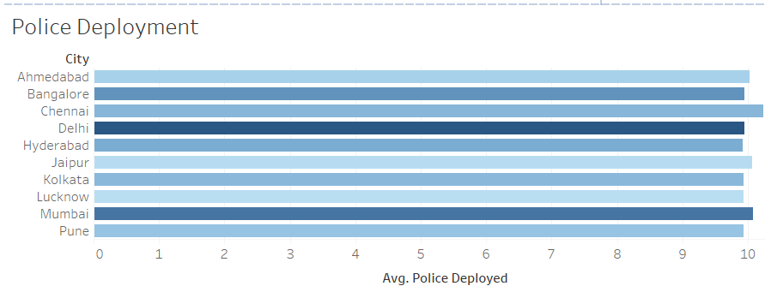

**e) POLICE DEPLOYMENT STATUS**

**f) Weapons used in Crime:**

1. Types of weapons used during the crime for top 10 cities is visualised.

2. Visualisation is done in the form of horizontal bar chart.

3. This helps the police department is to check the crime happened using which weapon.

4. Accordingly the police department can avoid such crimes in the future ie, in 2025.

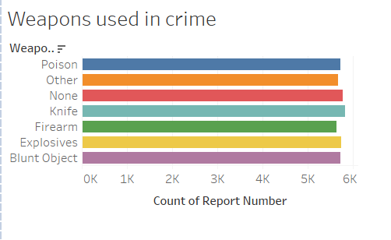

**f) WEAPONS USED IN CRIME**

**CONCLUSION:**

**\*** As per the police department’s request on approaching me (Tableau Professional) solved their problems by creating visualizations on:

**\*Top 10 cities with highest crime rate**

**\*Crime Trends over time**

**\*Case closure rates by crime domain**

**\*Victim Gender distribution**

**\*Police deployed status**

**\*Weapons used in crime**

*Finally added interactivity for the higher officials to view the crime analysis dashboard.

*Hence solved problem of police department by visually and analytically

**REFERENCES:**

* 1. <https://www.iaca.net/about-crime-analysis> Used for checking about the crime analysis and types of crime analysis
  2. <https://legalvidhiya.com/types-of-crime/> - Different crimes in India
  3. <https://www.orfonline.org/research/crime-in-india-a-critical-review-of-data-collection-and-analysis> - Referred for crime analysis in India
  4. <https://en.wikipedia.org/wiki/List_of_states_and_union_territories_of_India_by_crime_rate> - Checking the history of crime rates in India.